**Imagine we have a computer with Windows 10 for two-year courses. The first year can access two types of students: hardware and software (2 users for each type and 1 group for the first year). The second year can access security and servers (2 users for each type and 1 group for the second year).**

**The users above are standard, but we also have an advanced user called “responsible” with administrator permissions.**

**We want to create some folders in D:\ according to the following criteria:**

• A personal folder for each user, which can only be accessed by the corresponding user. They can do everything. You only need to create the folder for one of the users, since the others are similar.

• A read-only folder for all the students called “shared”. The responsible user is able to create or delete files and folders. The software user cannot access this folder.

• A folder only for first year students into the shared folder, where they can create files and folders, but not delete them. Second year students will not be able to access.

• Do the same as above for second year students (into the shared folder too). First year students will not be able to access.

Do the following:

1. **a) Explain the users and groups required for the computer.**
2. **b) Explain the folders we need according to the criteria above.**
3. **c) Set the NTFS permissions for all the users and groups in each folder created in part B. For the subfolders, consider two scenarios: inheritance and non-inheritance.**

You can use a table similar to below.

|  |  |  |  |  |  |  |  |  |  |
| --- | --- | --- | --- | --- | --- | --- | --- | --- | --- |
| **Folder name Allow** | | | | | **Deny** | | | | |
| User/Group | **Full Control** | **Modify** | **Read & Execute** | **Read** | **Write** | **Full Control** | **Modify** | **Read & Execute** | **Read** |

1. We need to create at least 2 users’ hardware, 2 users’ software, 2 users’ security, and 2 users’ servers. And at the same time 2 groups one for students of the first year(hardware and software) and another for students of the second year(security and servers).

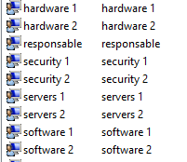

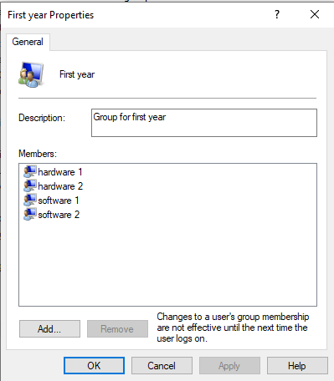

And the group for second year:

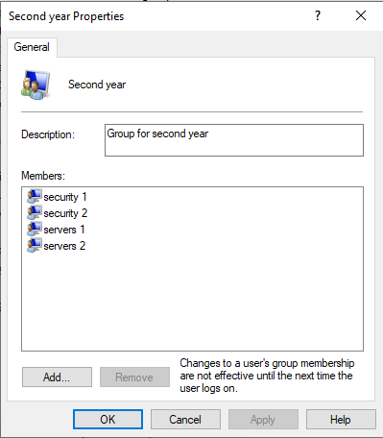

1. We need to create a folder for each member of the group(4), and 2 folders for first and second-year students. It is necessary to create one more folder shared.
2. The folder permissions will be as follows considering Full Control for “administrators”.

The first folder created for user hardware will have full control.

|  |  |  |  |  |  |  |  |  |  |
| --- | --- | --- | --- | --- | --- | --- | --- | --- | --- |
| **Folder name Allow** | | | | | **Deny** | | | | |
| User/Group | **Full Control** | **Modify** | **Read & Execute** | **Read** | **Write** | **Full Control** | **Modify** | **Read & Execute** | **Read** |
| hardware | **X** | **X** | **X** | **X** |  |  |  |  |  |

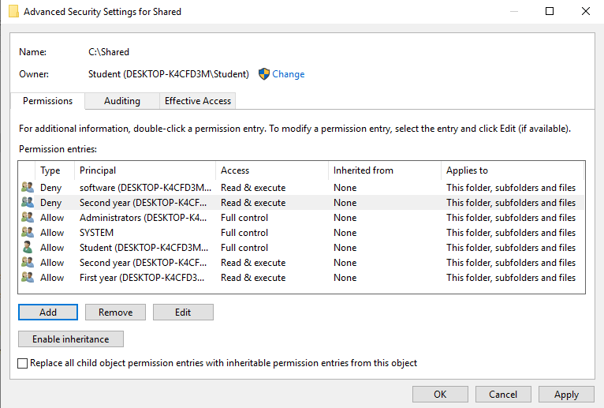

Shared folder

|  |  |  |  |  |  |  |  |  |  |  |
| --- | --- | --- | --- | --- | --- | --- | --- | --- | --- | --- |
|  | **Allow** | | | | | **Deny** | | | | |
| User/Group | **Full Control** | **Modify** | **Read & Execute** | **Read** | **Write** | **Full Control** | **Modify** | **Read & Execute** | **Read** | **Write** |
| First year |  |  | X | X |  |  |  |  |  |  |
| Second year |  |  | X | X |  |  |  |  |  |  |
| software |  |  |  |  |  |  |  |  | X |  |
| responsible |  | X | X | X | X |  |  |  |  |  |

With inheritance.

|  |  |  |  |  |  |  |  |  |  |  |
| --- | --- | --- | --- | --- | --- | --- | --- | --- | --- | --- |
|  | **Allow** | | | | | **Deny** | | | | |
| User/Group | **Full Control** | **Modify** | **Read & Execute** | **Read** | **Write** | **Full Control** | **Modify** | **Read & Execute** | **Read** | **Write** |
| first (inherited) |  |  | X | X |  |  |  |  |  |  |
| second  (inherited) |  |  | X | X |  |  |  |  |  |  |
| software  (inherited) |  |  |  |  |  |  |  |  | X |  |
| responsible  (inherited) |  | X | X | X | X |  |  |  |  |  |
| first (explicit) |  |  | X | X | X |  |  |  |  |  |
| second  (explicit) |  |  |  |  |  |  |  |  | X |  |